**JDK: Java Development Kit**

* It internally contains JRE + JVM.
* It provides all the tools to work with JAVA Language.

**JRE: Java Runtime Environment**

* It provides an environment to execute JAVA programs.
* It internally contains JVM, which is responsible to execute a JAVA program.

**JVM: Java Virtual Machine**

* JVM is a form of interpreter written in C language, through which we can execute our JAVA programs.

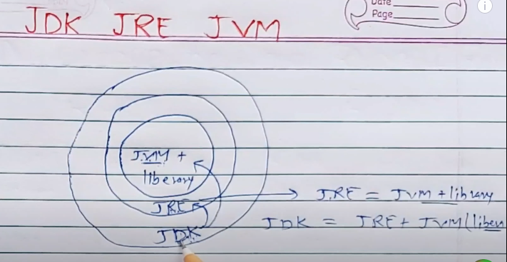

**JDK** is used by developers and students, where they write and implement their written JAVA codes in the system.

**JRE** is an environment which is used to create JAVA files. It contains the JVM + all the libraries used to execute a JAVA file.

**JVM** is a virtual machine used to create JAVA files.